Advanced Placement World History: 2017-18
Summer Assignment
Dear World History AP Student:

Congratulations on wanting to push yourself this up-coming school year. As an AP student, you will be held to a higher standard of excellence and personal responsibility for your performance in class. It is important that you possess strong time management skills, a strong work ethic, and the desire to learn. We will be moving at an accelerated pace through the curriculum and we encourage you to read ahead and work on your writing skills. We look forward to working with you towards a successful year in Advanced Placement World History. We applaud you on your choice to take AP World History (WHAP), a rigorous, college level history course. This course will prepare you for the challenges ahead, and certainly will allow you to get a head start on college in terms of college credit normally given for a score of 3, 4 & 5 on the AP exam, but also will prepare you to write well and think critically in all of your endeavors. Increasingly many universities assess rigor of courses undertaken in both admissions and in scholarship opportunities; your pursuit of an advanced track should serve you well.

While this course is challenging, persistent hard work and effort will pay off with great rewards. To that end, you are expected to complete the following assignment over the summer. Although summer is certainly a time of relaxation and family fun, it is also critical that we get a head start on this course due to the complexity of the task before us and the vastness of the course content, which begins at around 8,000 BCE and ends near the present. That is why we chose the AMSCO text World History: Preparing for the Advanced Placement Examination (2017 Edition), as our summer reading and it also will be used as an auxiliary text throughout the course. It encompasses the time frame we will cover, and it covers key themes of the course in an interesting way. The summer assignment serves two purposes: it is a test of the seriousness of your commitment to doing AP level coursework in World History and it helps you to gain a critical head start on your studies. A link to purchase this text can be found below.

The following assignment is MANDATORY, and must be completed before school starts. The attached course work will be graded based on correctness, depth, and quality of answers. Therefore, please read the text and the assignments carefully, and complete the assignment with attention to detail as the book will also be tested in the first week of school. You will also be tested over the material when you return to school.

Text:
The book can be purchased directly from the publisher, and the link is also posted on the AP World website. http://rchswhap.weebly.com/summer-assignment.html
World History: Preparing for the Advanced Placement Examination (AMSCO)
Item Number 1910101
ISBN-10 1680648004
ISBN-13 9781680648003
Copyright 2017
Publisher Perfection Learning Corp

Link to purchase text: https://www.perfectionlearning.com/social-studies/advanced-placement/world-history-ap-exam.html

Rules
1. Read, don’t skim, the book. Many WHAP students read this book, and it has become a favored choice by teachers because it is interesting and well-written.

2. Work independently. All of the questions must be answered in context of the book, so use of the internet will lead you astray, and will alert us to the fact that you weren’t able to read and comprehend the book at the level needed for this course. Additionally, all plagiarism policies are in order for summer reading, so you must complete this task independently, using only a dictionary and the book.

3. Terms and Questions: All work should be HANDwritten in complete sentences, and you are required to cite the page numbers for your answers.

4. Due Date: First Day of Class.

5. You will also have a quiz over the material when you return to school.

Again: All work MUST be handwritten. You will have a test over the summer assignment the first week we return from break.

World History: Preparing for the Advanced Placement Examination - AMSCO
This part of the assignment is due on the first day of class.
Purchase the review book, World History: Preparing for the Advanced Placement Examination from Perfection Learning for approximately $19. (See flyer on next page for purchasing information.) Please be sure that it is the 2017 edition which is aligned to the new AP World History exam.
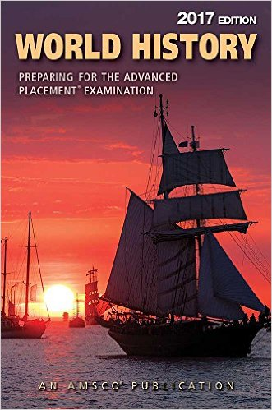
For your summer assignment you are required to read each of the following sections of the book and complete the attached work packet as well.
Refer to AMSCO Book
- Introduction (p.xii – xl)
- Period 1: Chapter 1 & 2 (p. 1 - 49)
The First Civilizations (p. 10 and/or use the internet to get a better definition and characteristics)

- Define civilization:

- What are the characteristics of civilizations?

- Where in the world did early core and foundational civilizations develop? (6 locations total)

Historical Perspectives: Was Farming a Mistake? (p. 11)
- Write down evidence that would support each side of this argument.

Farming as an Advance | Farming as a Mistake

Chapter 1 Multiple-Choice Questions (p. 12 – 15)

Question # | Answer | Question # | Answer
1.1 |  | 2.2
1.2 |  | 2.3
1.3 |  | 3.1
2.1 |  | 3.2

Other First Civilizations Top 5: For each of the civilizations below, write down the Top 5 important facts that you must know.

Civilization | Top 5
Phoenicians

Hebrews

Nubia

Kush

Axum

Chavin

Olmec

Pacific
Peoples

Chapter 2 Multiple-Choice Questions (p. 41 – 43)

Question # | Answer | Question # | Answer
1.1 |  | 2.2
1.2 |  | 2.3
1.3 |  | 3.1
2.1 |  | 3.2

Period 1 Review: Turning Point (p. 46)

- Why 600 B.C.E.?

Period 2: Organization and Reorganization of Human Societies,
c. 600 B.C.E. to c. 600 C.E.

Read through the Period Overview and the Key Concepts Box on p. 50-51 and highlight or underline the major topics and important details.
Chapter 3: Classical Civilization in Greece and Persia (p. 52 - 66)
Comparing Greek and Persian Empires (p. 64)

- Write 3 direct comparison statements (similarity or difference) about the Greek and Persian Empires

- _____________________________________________________________________________________________________________________________________________________________________________________________________________________________________________________________________
- _____________________________________________________________________________________________________________________________________________________________________________________________________________________________________________________________________
- _____________________________________________________________________________________________________________________________________________________________________________________________________________________________________________________________________
Chapter 3 Multiple-Choice Questions (p. 67 – 69)

Question # | Answer | Question # | Answer
1.1 |  | 2.2
1.2 |  | 2.3
1.3 |  | 3.1
2.1 |  | 3.2

Chapter 4: The Roman World (p. 72 – 86)

- Why did the Roman Empire collapse in 476 C.E.? (Be sure to use the Historical Perspectives Box as well as the chapter)

Chapter 4 Multiple-Choice Questions (p. 87 – 89)

Question # | Answer | Question # | Answer
1.1 |  | 2.2
1.2 |  | 2.3
1.3 |  | 3.1
2.1 |  | 3.2

Key Concepts: Our curriculum was developed by the College Board and is divided into six periods of world history. Within each period, there are key concepts that guide the course. We would like you to examine the first period of world history and the corresponding key concepts before the official start of the school year. This is the part of the summer assignment you must hand-write and turn in to your teacher the first week of school. We will have a TEST over this material the second week of school.
After reading all materials in the text, answer the following questions. Period One of AP World History: Technological and Environmental Transformations (c. 8000 BCE. to c. 600 BCE.)
Key Concept 1.1 – Big geography and the Peopling of the Earth
Using the AMSCO Text, answer the following question.

- How did the environment affect the earliest human migrations?

- What tools did people use to adapt to the environment? How were those tools disseminated?

- Compare the effects of pastoral nomads and Neolithic communities on the environment.

- Explain how the change from hunting and gathering to pastoralism and farming affected social and gender structures.

- How did increased economic production lead to more stratified societies?

- How did the development of specialized labor systems interact with the development of social hierarchies?

- How were the activities of pastoralists important to settled people?

- How did religions develop and affect societies?

- How have the functions of governments changed over time?

- How did environmental factors impact human societies?

- How were cultural factors used in the creation and maintenance of political power?

- How did law codes function as a means to maintain social continuities?

- How were cultural factors used in the creation and maintenance of political power?

- How did the environment shape the nature of Egyptian civilization?

- How did beliefs and practices spread as a result of expanding networks of communication and exchange?

- How did cross cultural interaction between Egypt and Nubia result in the diffusion of technology and culture?

Key Concept 1.2 – The Neolithic Revolution and Early Agricultural Societies

1. What was the Neolithic Revolution, and what caused this huge transformation? What regions of the
world experienced Neolithic Revolutions, and when did they take place?
2. What were the main changes caused by the Neolithic Revolution? Make a chart showing the following types of
changes:
- social
- demographic
- environmental
- political
- economic

3. Study the map below. What were the main crops and animals that were domesticated during the
Neolithic Revolution? What differences do you notice between Eurasia and the Americas? (If you have trouble reading the map, search the title of the map and you should get several images that will help. But, make sure the site you use is reliable!)

Early Spread of Agriculture (c. 10,000 BCE – 1,000 BCE)

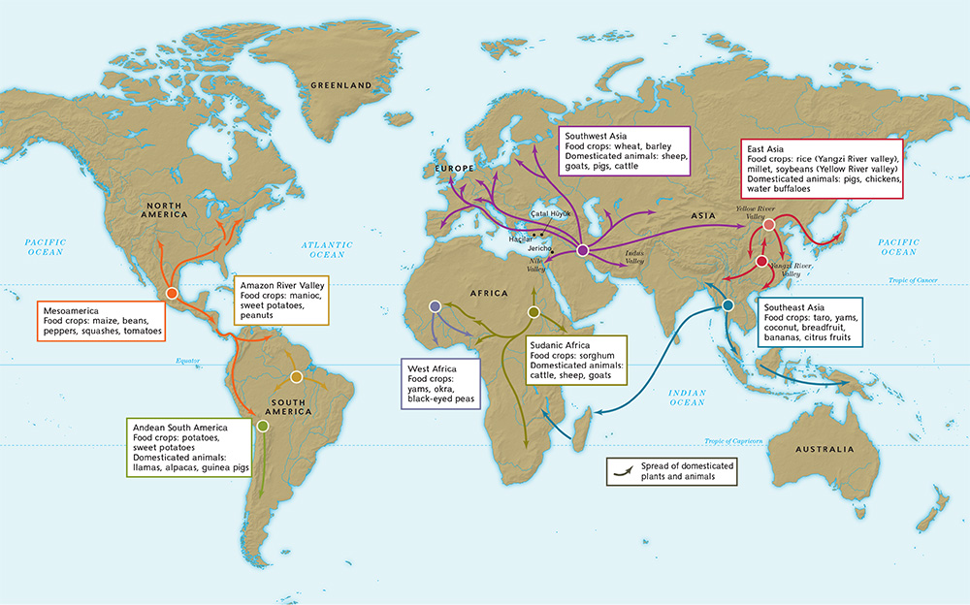

Key Concept 1.3 – The Development and Interactions of Early Agricultural, Pastoral, and Urban Societies
- Where were the first four river valley civilizations located, and what did geography have to do with their development?
- What are the seven key characteristics of civilizations?
- Locate the following core and foundational civilizations and label them on the map below:
- Mesopotamia in the Tigris and Euphrates River Valleys
- Egypt in the Nile River Valley
- Mohenjo-Daro and Harappa in the Indus River Valley
- Shang in the Yellow River or Huang He Valley
- Olmecs in Mesoamerica
- Chavin in Andean South America

- Where did early pastoral societies emerge? Label some regions in which pastoral societies emerged on the map below. Feel free to print out a larger world map if necessary.

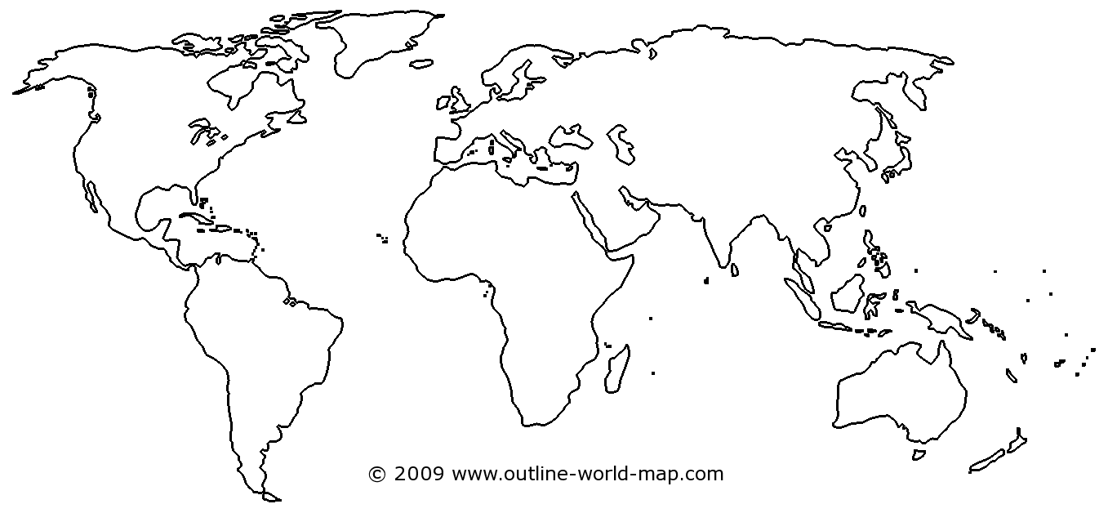
- What characterized pastoral societies? http://history-world.org/nomads.htm

- How did pastoral societies interact with early agricultural civilizations? http://history-world.org/nomads.htm

Map Activity
On the outline map of the ancient Near East below, identify the locations of the following:
Tigris River | Red Sea | Persian civilization | Nineyah
Euphrates River | Sahara Desert | Hebrew civilization | Jerusalem
Nile River | Sumerian civilization | Egyptian civilization | Memphis
Mediterranean Sea | Hittite civilization | Babylon | Persepolis
Persian Gulf

the near east

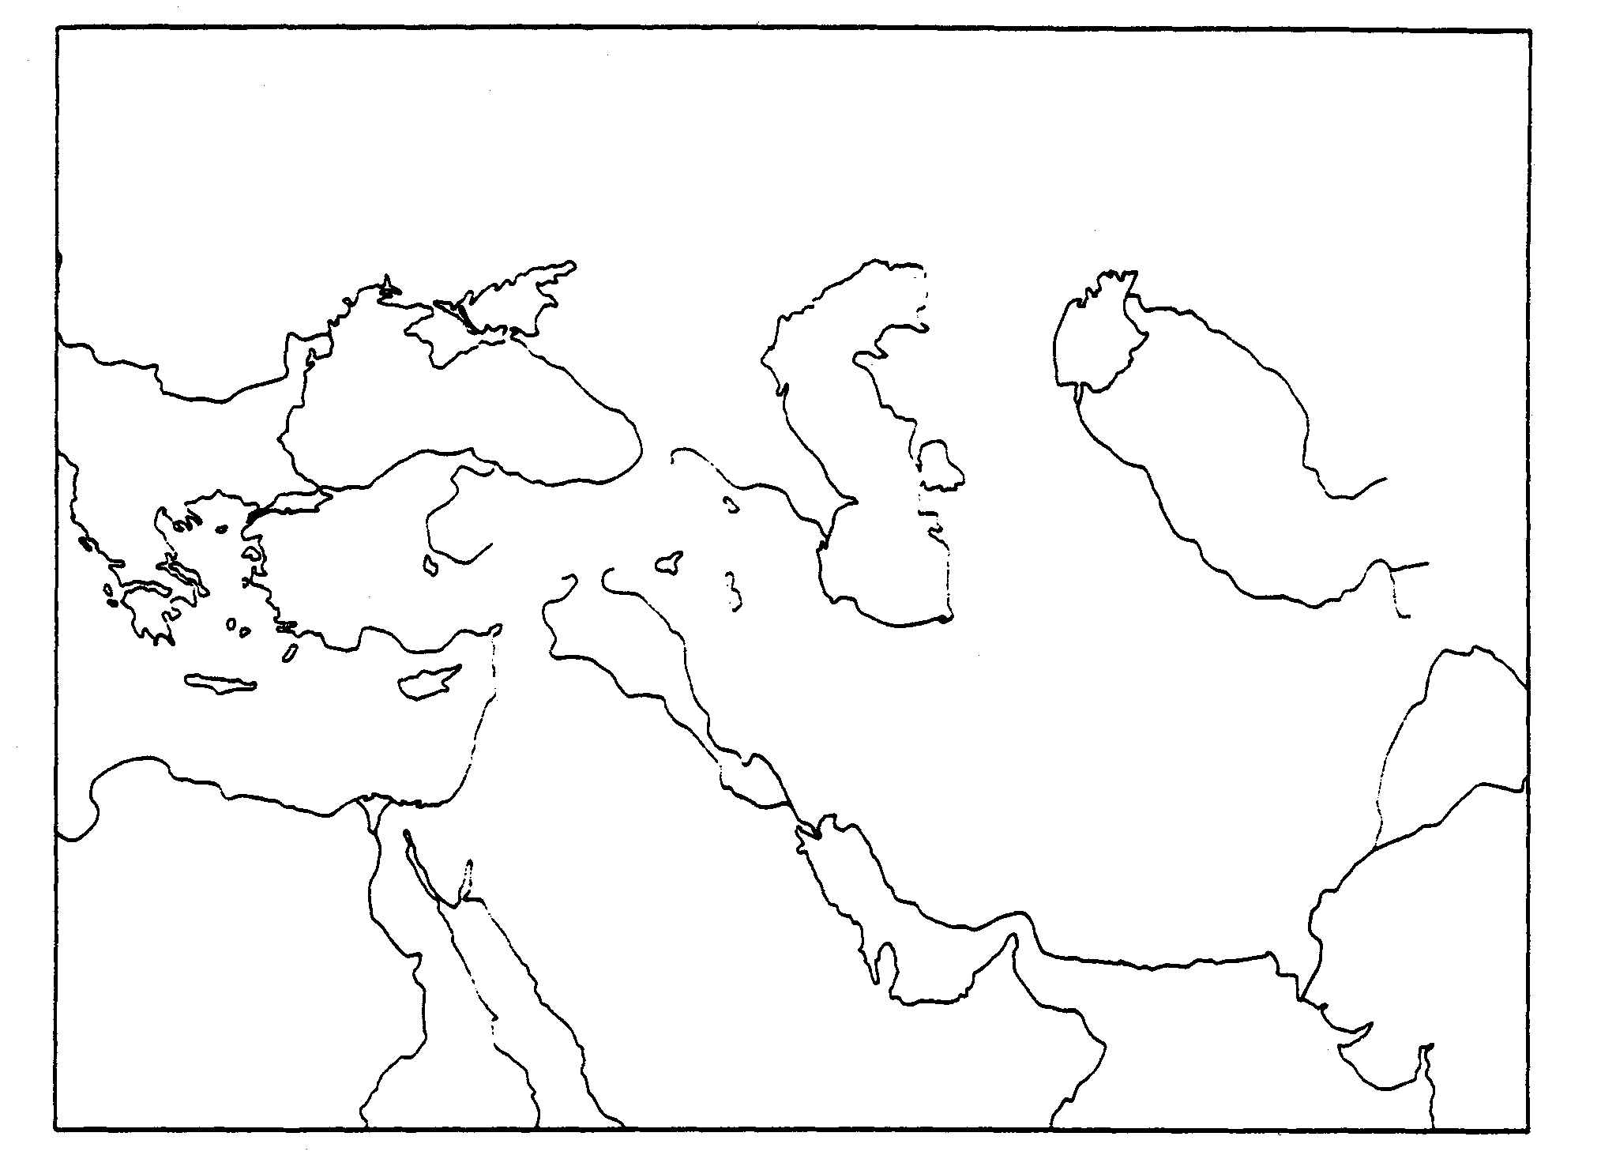
Mediterranean Sea

On the outline map of the ancient East below, identify the locations of the following:
China | Indus River Valley | Ganges River
Huang He | Harrapa
Yangtze | Mohenjo Daro
Indian Ocean | Shang Dynasty
South China Sea | Zhou Dynasty

the east
